The 50th Annual Nassau Coaches Invitational
Saturday, April 28th, 2018 – MacArthur H.S. (9am Start)

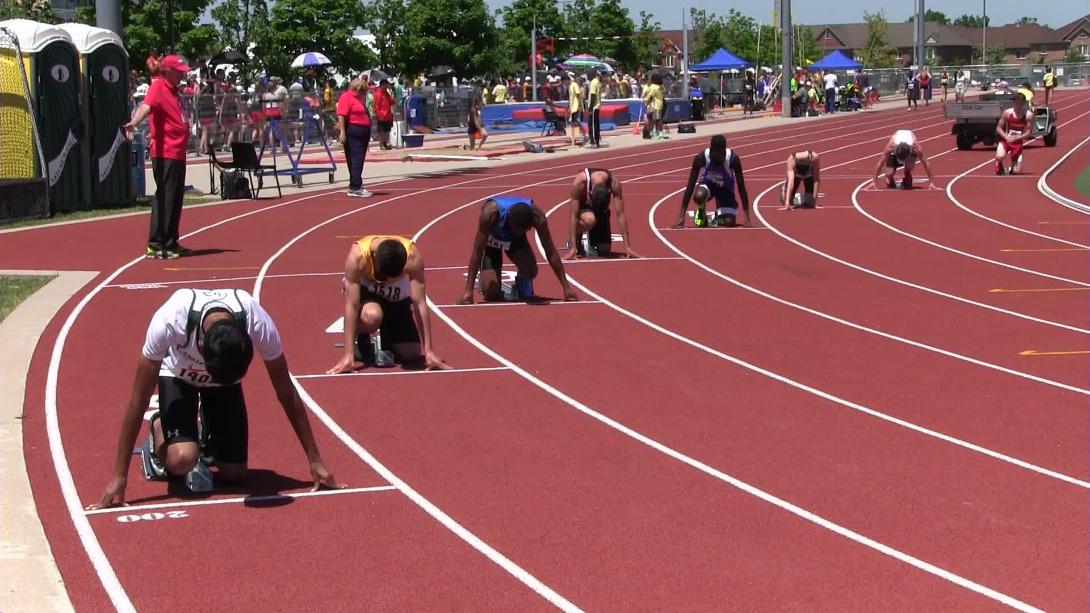

NCTCA Officers: Board of Directors:
President Michael Ringhauser (EM) Adam McKenzie (Great Neck North)
Vice President Kristin Frazer (Section Coord.) Dennis Kornfield (Uniondale)
Treasurer Fred DeRuvo (Island Trees) Bob Busch (Garden City)
Secretary Katie DeRuvo (Island Trees) Jordan Ashley (Wantagh)

The MacArthur School District has provided us with an outstanding site, tremendous cooperation, and generous support for this event. We should express our appreciation for their role and treat their site and personnel with the utmost respect. We ask that you leave your team’s space as clean as you found it. We thank the MacArthur track coaches and student-athletes for their cooperation and assistance throughout the invitational.

BACK THIS YEAR:
Giant marquee with announcements, clerk-in times, and results.
FAT results for all events posted on www.just-in-time-racing.com as well as at the meet itself.

Meet Directors: Michael Ringhauser (EM) and Fred DeRuvo (IT)
Site Coordinator: Dennis Gorman (Mac)

The Nassau County Track Coaches Association
50th Annual Track and Field Invitational
Saturday, April 28th, 2018 – MacArthur High School (9am Start)

Meet Directors: Michael Ringhauser and Fred DeRuvo
- This meet is co-sponsored by the NCTCA and MacArthur High School
- All Section VIII, NYSPHSAA, and National Federation rules are enforced
- Certified NYS Officials will be present at all events contested
- Decision of the jury is final on all appeals at the invitational
- Site Coordinator: Dennis Gorman; Medical Staff will be on-site

All Schools: Nassau teams will be using their competitor numbers for this meet.
NSCHSAA and Suffolk teams will be using numbers assigned by Tony Toro.

Fr/So Events: Limited to runners in 7th, 8th, 9th and 10th grade.
Please note that 7th and 8th grade competitors must have gone through the classification process and be on your varsity roster to be able to compete.

Awards: Medals to the Top 6 finishers in ALL EVENTS!
School Plaque to FASTEST OVERALL TIME in the three OPEN RELAYS.

Seeding: Running Events – Labels needed with name, competitor number, school.
Field Events – 3x5 index cards with name, competitor number, school, seed.
Relays – 3x5 index cards with names, competitor numbers, school, and seed.

Field Events: All first attempts will be measured. After that, athletes must reach the standards below in order to receive a measurement.

Open Shot Put Boys – 35 Girls – 25
F/S Shot Put Boys – 30 Girls – 20
Open Discus Boys – 90 Girls – 75
F/S Discus Boys – 80 Girls – 60
Open Long Jump Boys – 17 Girls – 14
F/S Long Jump Boys – 15 Girls – 12
Open Triple Jump Boys – 36 Girls – 28
F/S Triple Jump Boys – 32 Girls – 24

Note: Please submit all paperwork as soon as possible. DO NOT ASSUME THAT YOUR SCHOOL WILL SEND US A COPY – as the coach, YOU must send us a copy!

Questions: Michael Ringhauser (Phone) 631-245-1564
(Email) michael.ringhauser@yahoo.com
ALL ENTRIES ARE DUE BY WEDNESDAY, APRIL 25th, 2018.
LATE ENTRIES MAY NOT BE ACCEPTED INTO THE INVITATIONAL.
Order of Events: Boys, then Girls in all running events
400 Hurdles Final – Open Only

1600/1500 Final – Open, Sophomores, Freshmen (3200/3000 Clerk-In)

100 Semi-Final – Open Only

110/100 Hurdles Final – Open Only

400 Final – Open, Sophomores, Freshmen

100 Final – Two Sections

800 Final – Open, Sophomores, Freshmen

3200/3000 Final – Open Only
MAX OF ONE SECTION EACH – REJECTED RUNNERS MAY RUN IN THE 1600/1500 OR ANY OTHER EVENT OF THEIR CHOICE. CLERK IN WILL TAKE PLACE DURING THE CLERK IN FOR THE 1600/1500 EVENT.

200 Final – Open Only

3000 Steeple Chase Open Boys Only (2 Sections Max)

2000 Steeple Chase Open Girls Only (2 Sections Max)

4x100 Final – Open, Frosh/Soph

4x800 Final – Open, Frosh/Soph

4x400 Final – Open, Frosh/Soph

Field Event Order: * Unseeded sections may have reduced opportunities based on time.
Open Long Jump Boys, followed by girls - In-Field Runway
Frosh/Soph Long Jump Boys, followed by girls - Straightaway Runway
Open Triple Jump Girls, followed by boys - In-Field Runway
Frosh/Soph Triple Jump Girls, followed by boys - Straightaway Runway
Open Shot Put Girls, followed by boys - Cage closest to school
Frosh/Soph Shot Put Girls, followed by boys - Location TBA
Open Discus Boys, followed by girls - Cage furthest from school
Frosh/Soph Discus Boys, followed by girls - Location TBA
High Jump Open Boys, Open Girls, Frosh/Soph Boys, Frosh/Soph Girls
Pole Vault Open and Frosh/Soph Girls; then Open and Frosh/Soph Boys
REMEMBER THAT CARDS ARE NEEDED FOR ALL FIELD EVENTS!
Information Needed: Athlete’s Name, School, Competitor Number, Seed

Nassau Coaches Invitational Entry Grid
PLEASE FILL THIS OUT ACCURATELY SO WE CAN EFFICITENTLY MANAGE TIME!
Boys and Girls Must Use Separate Entry Forms!
EVENT | OPEN | SOPH | FROSH | FRESH/SOPH
400 Hurdles |  | NA – XXXXXX | NA – XXXXXX | NA – XXXXXX
1600/1500 |  |  |  | NA – XXXXXX
100 |  | NA – XXXXXX | NA – XXXXXX | NA – XXXXXX
110/100 H |  | NA – XXXXXX | NA – XXXXXX | NA – XXXXXX
400 |  |  |  | NA – XXXXXX
800 |  |  |  | NA – XXXXXX
3200/3000 |  | NA – XXXXXX | NA – XXXXXX | NA – XXXXXX
Steeple Chase |  | NA – XXXXXX | NA – XXXXXX | NA - XXXXXX
200 |  | NA – XXXXXX | NA – XXXXXX | NA – XXXXXX
High Jump |  | NA – XXXXXX | NA – XXXXXX
Long Jump |  | NA – XXXXXX | NA – XXXXXX
Triple Jump |  | NA – XXXXXX | NA – XXXXXX
Pole Vault |  | NA – XXXXXX | NA – XXXXXX
Shot Put |  | NA – XXXXXX | NA – XXXXXX
Discus |  | NA – XXXXXX | NA – XXXXXX
4x100 |  | NA - XXXXXX | N/A - XXXXX
4x800 |  | NA – XXXXXX | NA – XXXXXX
4x400 |  | NA – XXXXXX | NA – XXXXXX

School: __________________________________ Boys/Girls: __________________________

Coach: __________________________________ Phone: _____________________________

Email: ___________________________________ School Phone: _______________________

Billing Information: All fees associated are considered ENTRY FEES, not participation fees.
Make All Checks Payable to: NCTCA
The cost of officials will be billed through BOCES
- Non-Section VIII schools will be billed $50 for officials.
Option One:
Number of Individuals _____ x $5.00 = ____________________________________

Number of Relays _____ x $20.00 = ____________________________________

Option Two: BLANKET ENTRY OF $250 PER TEAM (NOT PER SCHOOL)
Note that this is $100 cheaper than previous years in order to help our teams.
YOU STILL HAVE TO FILL OUT A GRID FOR MEET MANAGEMENT.

Total Owed: __________________________ (Non-Section VIII Schools Add $50 for Officials)

Send Entries and Payment To: Fred DeRuvo Fax Fred DeRuvo
730 Boelsen Drive OR (516) 334-5461
Westbury, NY 11590 FAX BEFORE 9PM ONLY

